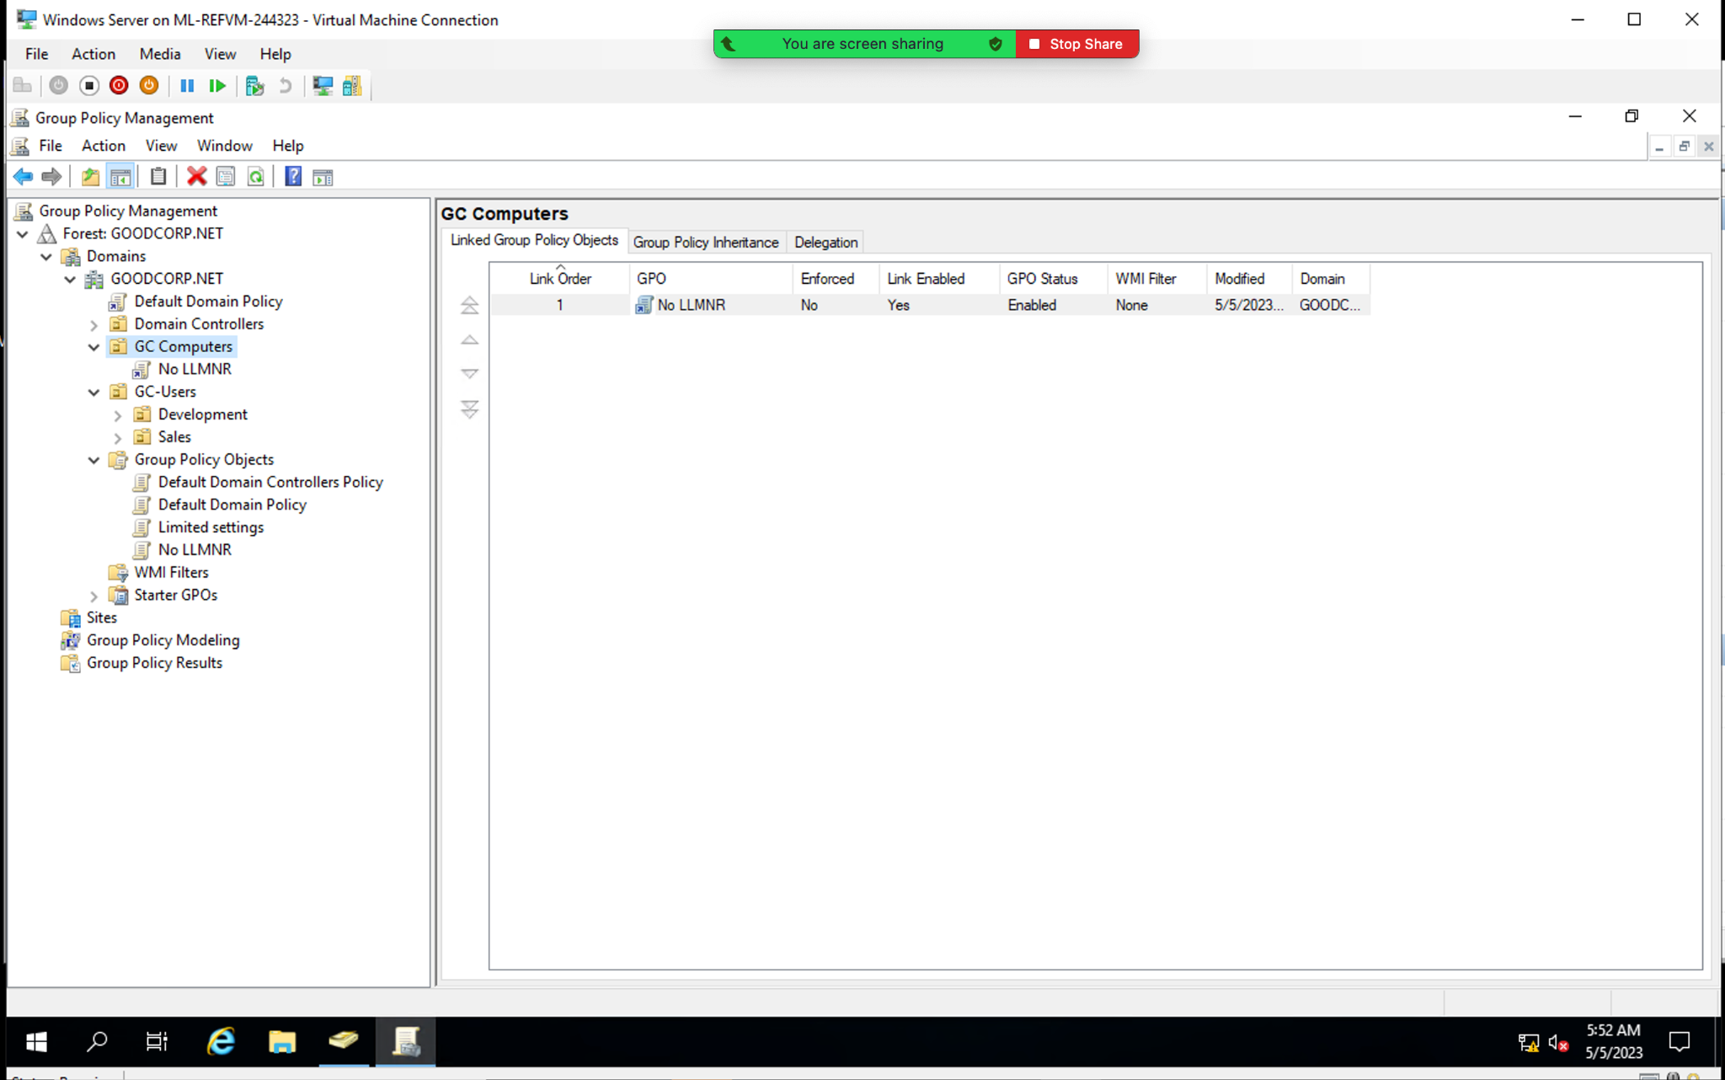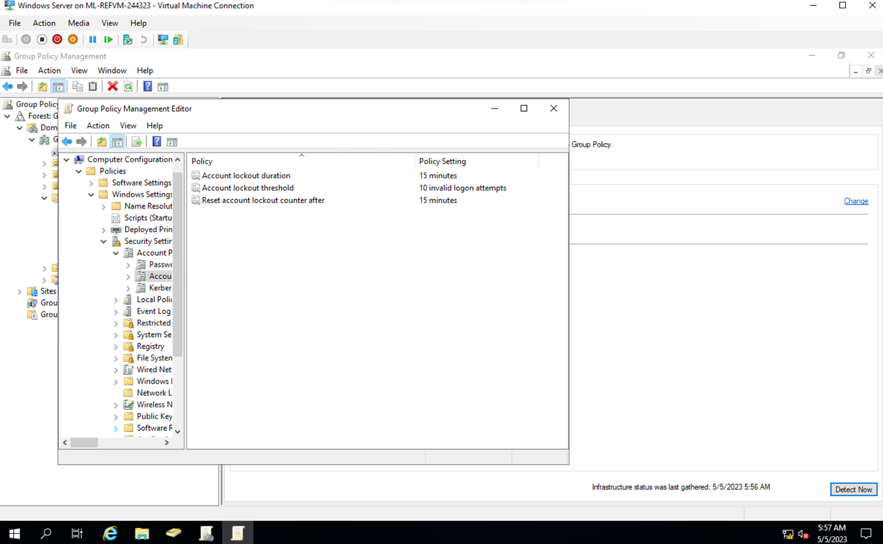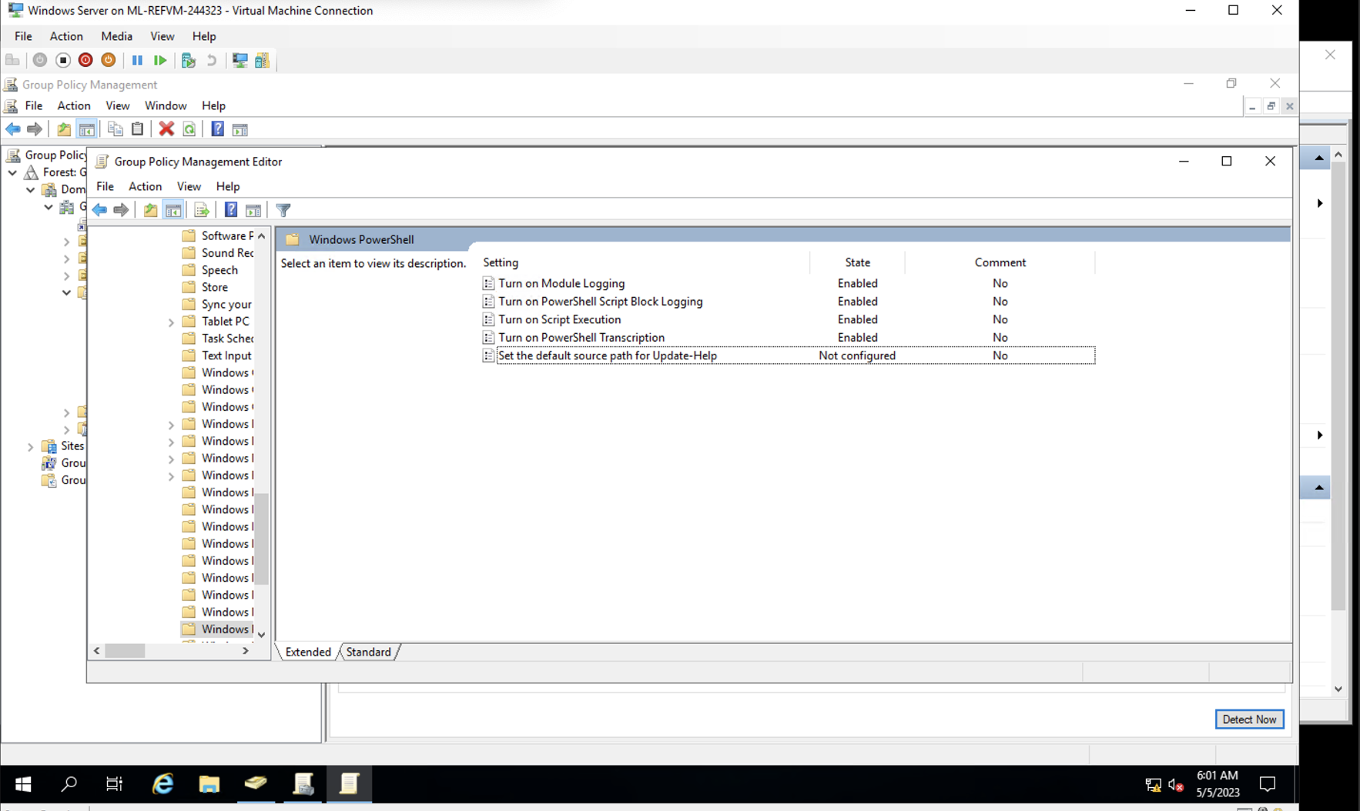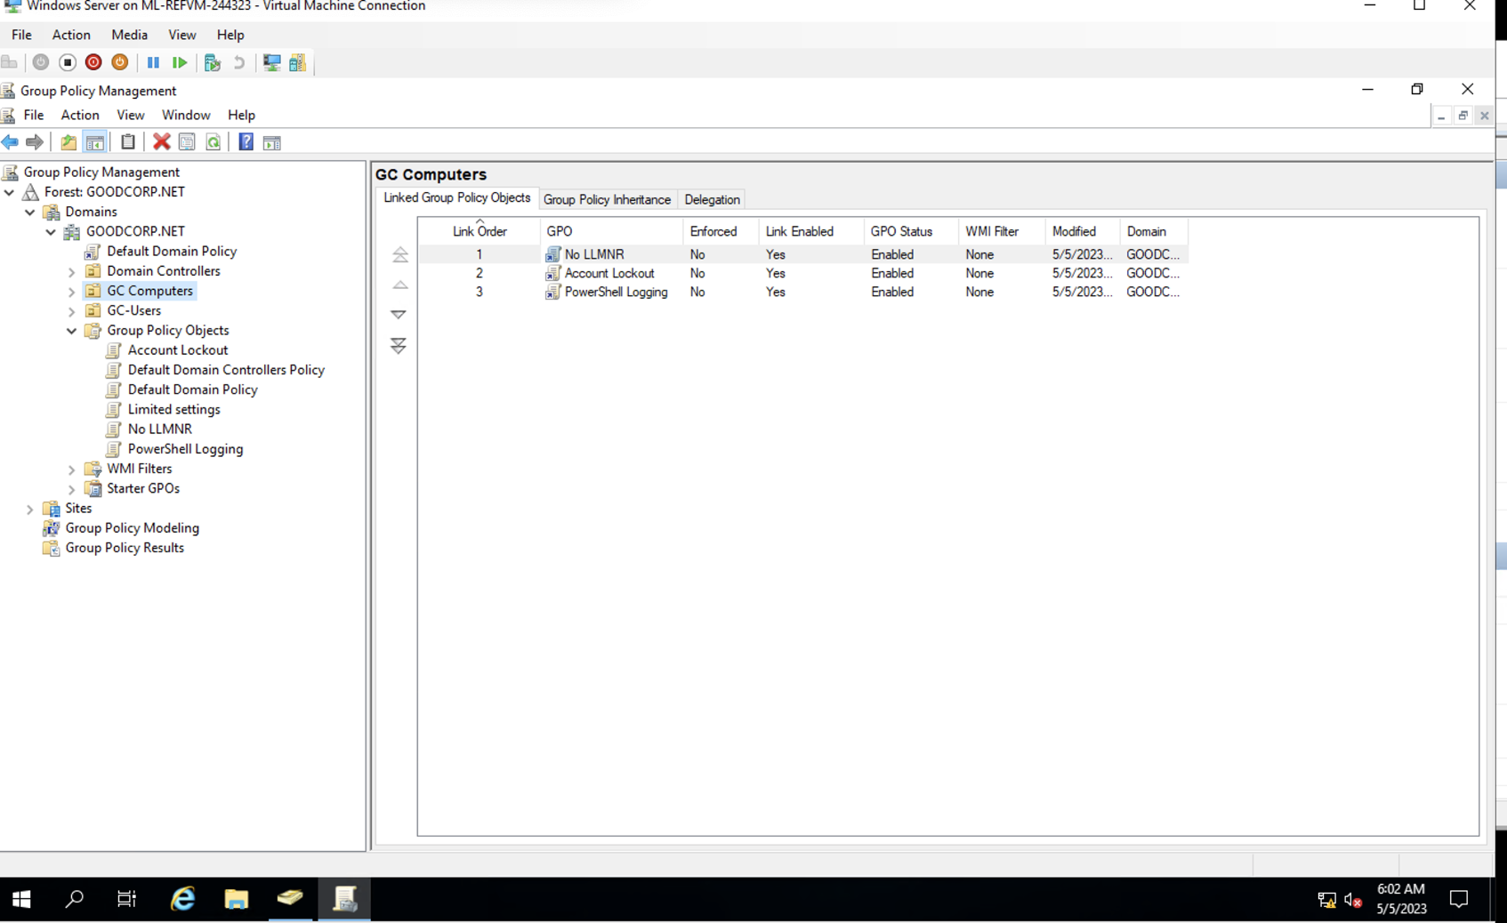

$directory = Get-ChildItem -Directory -Path .

foreach ($item in $directory) {

Write-Host "Item: $($item.FullName)"

Get-Acl -Path $item.FullName | Format-List

}

$files = Get-ChildItem -File -Path .

foreach ($item in $files) {

Write-Host "Item: $($item.FullName)"

Get-Acl -Path $item.FullName | Format-List

}